Discerning Disciples
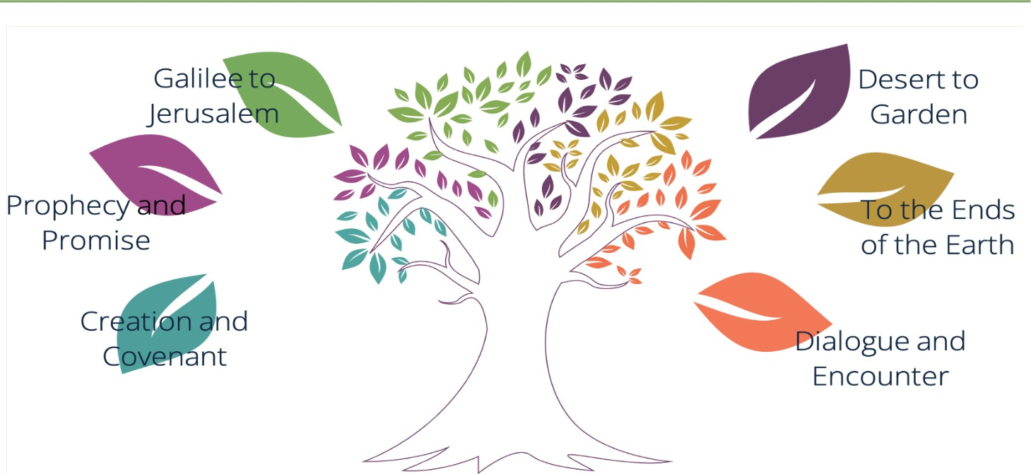
Discerning Disciples is the religious education curriculum for Catholic primary schools in the Archdiocese of Birmingham. It has been developed in full accordance with the Religious Education Directory (RED), the curriculum directory issued by the Catholic Bishops' Conference of England and Wales which sets out what pupils in Catholic schools should know, understand, and be able to do in religious education.
The curriculum supports the shared mission of our diocesan family of schools: forming Christ-centred pilgrims of hope with kind hearts, questioning minds, a thirst for knowledge and a hunger for justice.
Discerning Disciples is organised into the six 'branches' of the RED, which align with the Catholic Church's liturgical
year:
Creation and Covenant Desert to Garden
Prophecy and Promise To the Ends of the Earth
Galilee to Jerusalem Dialogue and Encounter
Across these branches, pupils encounter Sacred Scripture, deepen their knowledge and understanding of Catholic faith and teaching, study prayer, liturgy, and the sacraments, and consider how faith is lived in the world. Through Dialogue and Encounter, they also learn about other faiths and religions, and develop the knowledge, understanding, and dispositions needed for respectful dialogue.
At the heart of Discerning Disciples are the RED's three ways of knowing: understand, discern and respond. Pupils are therefore encouraged not simply to acquire religious knowledge, but to think deeply about what they learn, make connections, consider different perspectives and make thoughtful judgements. In doing so, religious education helps pupils to grow in knowledge, wisdom and understanding and to reflect on how what they learn might shape the way they live.

